**Anita Yadav**

**Mobile testing Day2 assignment**

1. **List down the things you cannot test on an Emulator but on Real Devices?**

1)We can not check the actual behaviour like interruption of one app while we are working on another app.

2)Reliability of the product that whether the app has met the requirement of the user or not can only be tested on Real Device.

3)battery drainage can only be checked on the real devices

4)Dependency of one app on another can be tested i.e interoperability can only be tested on the real devices

5)Screen resolution and brightness can be tested on the real devices more accurately.

1. **What All Major Networks to Be Considered While Performing Application Testing?**

Various Networks are 2G,3G,4G, and WIFI.2G is the slowest network and it advisable to test on slowest network to test the performance of our application.

1. **What are the google core quality guidelines for Mobile Apps, Explain guidelines for Functionality?**

Android users expect high-quality apps. App quality directly influences the long-term success of the app in terms of installs, user ratings and reviews, engagement, and user retention. We assess the core aspects of quality in our app, through a compact set of quality criteria and associated tests. All Android apps should meet these criteria.

Before publishing any apps, test them against these criteria to ensure that they function well on many devices, meets Android standards for navigation and design, and are prepared for promotional opportunities in the Google Play store.

The guidelines for Functionality are:

1.Permissions-

The app requests only the absolute minimum permissions that it needs to support core functionality.

The app does not request permissions to access sensitive data (such as Contacts or the System Log) or services that can cost the user money (such as the Dialer or SMS), unless related to a core capability of the app.

2. Install Location-

The app functions normally when installed on SD card (if supported by app).Supporting installation to SD card is recommended for most large apps (10MB+).

3. Audio-

Audio does not play when the screen is off, unless this is a core feature (for example, the app is a music player).

Audio does not play behind the lock screen, unless this is a core feature.

Audio does not play on the home screen or over another app, unless this is a core feature.

Audio resumes when the app returns to the foreground, or indicates to the user that playback is in a paused state.

4. UI and Graphics-

The app supports both landscape and portrait orientations (if possible).

Orientations expose largely the same features and actions and preserve functional parity. Minor changes in content or views are acceptable.

The app uses the whole screen in both orientations and does not letterbox to account for orientation changes.

Minor letterboxing to compensate for small variations in screen geometry is acceptable.

User/App States-

The app should not leave any services running when the app is in the background, unless related to a core capability of the app.

For example, the app should not leave services running to maintain a network connection for notifications, to maintain a Bluetooth connection, or to keep the GPS powered-on.

The app correctly preserves and restores user or app state.

1. **Write down test cases for Push notification.**

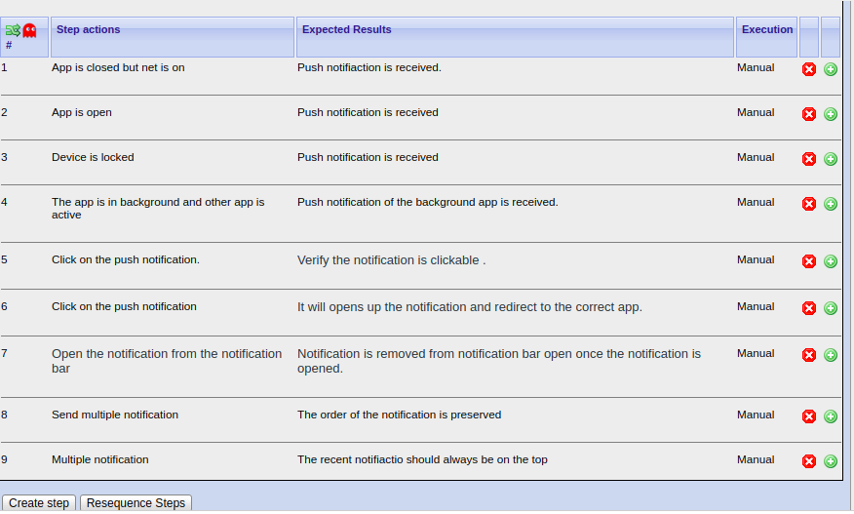

**5.What do you understand by Device and OS fragmentation in mobile application testing?**

1. Mobile device fragmentation is a phenomenon that occurs when some mobile users are running older versions of an operating system, while other users are running newer versions.

Mobile device fragmentation can be a problem for software developers who must create different versions of the same app in order to make sure it works correctly with different versions of a given OS.

It can also be a problem for IT departments because different operating versions have different capabilities, which can make them harder to manage and secure.

Mobile device fragmentation is often associated with Android, Google’s mobile OS. It is not as much of an issue with iOS devices.

2. OS Fragmentation

OS Fragmentation arises due to different versions of OS. Both Android & iOS has around 10+ different versions available.

Developers have to make sure that their app is running on all different versions of OS(whether it is Android, iOS or any other OS).

There should be seamless user experience regardless of the OS installed in device.

**6.What is deep linking? What do you understand by deferred deep linking?**

In the context of mobile apps, deep linking consists of using a uniform resource identifier (URI) that links to a specific location within a mobile app rather than simply launching the app

Deferred deep linking is one aspect of mobile deep linking. It describes the principle of deep linking into an app that is not yet installed. In this case, deep linking will be "deferred" until the application will be installed by the user. This implies that clicking (or otherwise invoking) the deep link causes:

An app store to open (Google Play/IOS or Windows App Store depending on the user's device) to enable the user to install the app

Once the app is installed, the link is invoked with its original URL and parameters so that the newly installed app can handle the invocation.